**Regions:**

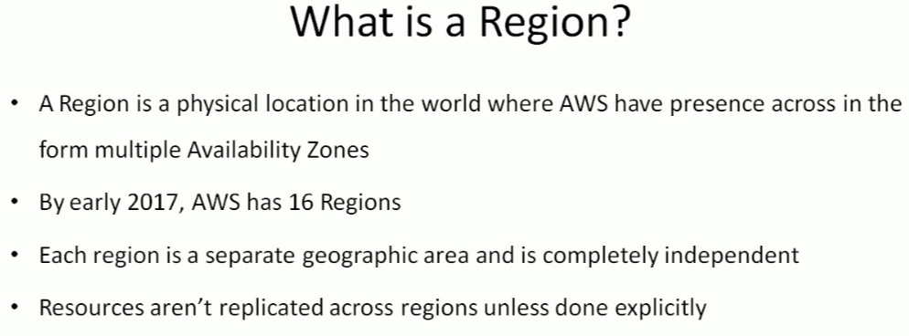

* Some services not available in all the regions
* Almost all the services are available in northern Virginia region
* Cloudping.info to check the latency

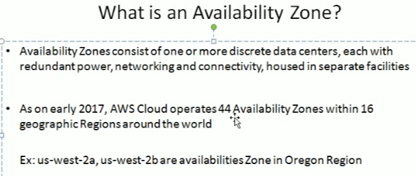

* Availability zone is nothing but another location of data centre in same region for high availability

